OpenCV install for Deep Learning

Steps are primarily the same however you will need to install OpenCV 4.0.0 instead of OpenCV 3.4.4. Mainly we need to make sure that OpenCV is built with Cuda and cudnn especially so that we are able to draw our bounding box predictions when we test our trained models and visualize our results this way.

Note that anywhere you see 3.4.4 referenced in the tutorial just replace it with 4.0.0

**Modification to step 2.)**

Opencv

<https://github.com/opencv/opencv/archive/4.0.0.zip>

Opencv Contrib

<https://github.com/opencv/opencv_contrib/releases/tag/4.0.0>.zip

----------------------------------------------------------------------------------------------------------------------------

**Modification to step 4.)**

Install the ccmake gui

In the “Configure OpenCV with CMake” section and run these in the terminal instead:

cd ~/opencv

mkdir build

cd build

ccmake ..

Some flags you will need to set manually, check that cuda flags are the same by manually checking your file paths, you will need to set the python flags to the location where your python is installed. It’s very important that the configuration is set up properly otherwise the libraries will not build. We need to set the CUDA_nppi_LIBRARY flag manually, and also the python paths manually.

-D CUDA_nppi_LIBRARY= /usr/local/cuda-9.0/lib64/libnppial.so;/usr/local/cuda-9.0/lib64/libnppicc.so;/usr/local/cuda-9.0/lib64/libnppicom.so;/usr/local/cuda-9.0/lib64/libnppidei.so;/usr/local/cuda-9.0/lib64/libnppif.so;/usr/local/cuda-9.0/lib64/libnppig.so;/usr/local/cuda-9.0/lib64/libnppim.so;/usr/local/cuda-9.0/lib64/libnppist.so;/usr/local/cuda-9.0/lib64/libnppisu.so;/usr/local/cuda-9.0/lib64/libnppitc.so

Python path setting example

//Path to Python interpretor

PYTHON2_EXECUTABLE:FILEPATH=/home/mclovin/.virtualenvs/cv/bin/python

//Python include dir

PYTHON2_INCLUDE_DIR:PATH=/home/mclovin/.virtualenvs/cv/include/python2.7

//Python include dir 2

PYTHON2_INCLUDE_DIR2:PATH=

//Path to Python library

PYTHON2_LIBRARY:FILEPATH=/usr/lib/python2.7/config-x86_64-linux-gnu

//Path to Python debug

PYTHON2_LIBRARY_DEBUG:FILEPATH=

//Path to numpy headers

PYTHON2_NUMPY_INCLUDE_DIRS:PATH=/home/mclovin/.local/lib/python2.7/site-packages/numpy/core/include

//Where to install the python packages.

PYTHON2_PACKAGES_PATH:PATH=

//Path to Python interpretor

PYTHON3_EXECUTABLE:FILEPATH=/home/mclovin/.virtualenvs/cv/bin/python3

//Python include dir

PYTHON3_INCLUDE_DIR:PATH=/home/mclovin/.virtualenvs/cv/include/python3.6m

//Python include dir 2

PYTHON3_INCLUDE_DIR2:PATH=

//Path to Python library

PYTHON3_LIBRARY:FILEPATH=/usr/lib/python3.6/config-3.6m-x86_64-linux-gnu/libpython3.6m.so

//Path to Python debug

PYTHON3_LIBRARY_DEBUG:FILEPATH=

//Path to numpy headers

PYTHON3_NUMPY_INCLUDE_DIRS:PATH=/home/mclovin/.virtualenvs/cv/lib/python3.6/site-packages/numpy/core/include

//Where to install the python packages.

PYTHON3_PACKAGES_PATH:PATH=

----------------------------------------------------------------------------------------------------------------------------

Next we can actually run cmake using these flags when running the cmake command

cmake -D CMAKE_BUILD_TYPE=RELEASE -D CMAKE_CXX_COMPILER=/usr/bin/g++-6 -D CMAKE_C_COMPILER=/usr/bin/gcc-6 -D CMAKE_INSTALL_PREFIX=/usr/local -D WITH_CUDA=ON -D ENABLE_FAST_MATH=1 -D CUDA_FAST_MATH=1 -D WITH_CUBLAS=1 -D INSTALL_PYTHON_EXAMPLES=ON -D OPENCV_EXTRA_MODULES_PATH=../../opencv_contrib/modules -D WITH_TBB=ON -D WITH_LAPACK=OFF -D CUDA_GENERATION=Maxwell -D OPENCV_GENERATE_PKGCONFIG=ON -D OPENCV_PYTHON3_VERSION=ON ..

-D CUDA_nppi_LIBRARY= /usr/local/cuda-9.0/lib64/libnppial.so;/usr/local/cuda-9.0/lib64/libnppicc.so;/usr/local/cuda-9.0/lib64/libnppicom.so;/usr/local/cuda-9.0/lib64/libnppidei.so;/usr/local/cuda-9.0/lib64/libnppif.so;/usr/local/cuda-9.0/lib64/libnppig.so;/usr/local/cuda-9.0/lib64/libnppim.so;/usr/local/cuda-9.0/lib64/libnppist.so;/usr/local/cuda-9.0/lib64/libnppisu.so;/usr/local/cuda-9.0/lib64/libnppitc.so -D BUILD_EXAMPLES=ON ..

-----------------------------------------------------

Sudo apt-get install python3.6-dev

Sudo apt-get install python2.7-dev

Sudo apt install python3-pip

Sudo apt install python-pip

pip install numpy

pip3 install numpy

sudo pip3 install virtualenv virtualenvwrapper

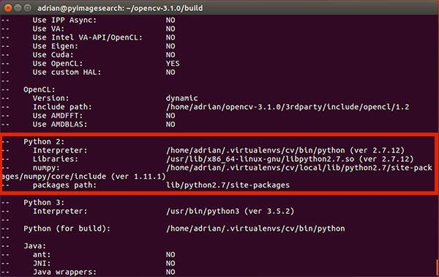

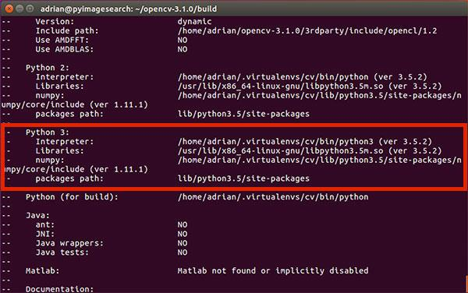

Configure configure via cmakecache.txt if not showing up

//Path to Python interpretor

PYTHON3_EXECUTABLE:FILEPATH=/home/modeste/.virtualenvs/dl4cv/bin/python3

//Python include dir

PYTHON3_INCLUDE_DIR:PATH=/home/modeste/.virtualenvs/dl4cv/include/python3.6m

//Python include dir 2

PYTHON3_INCLUDE_DIR2:PATH=

//Path to Python library

PYTHON3_LIBRARY:FILEPATH=/usr/lib/x86_64-linux-gnu/libpython3.6m.so

//Path to Python debug

PYTHON3_LIBRARY_DEBUG:FILEPATH=

//Path to numpy headers

PYTHON3_NUMPY_INCLUDE_DIRS:PATH=/home/modeste/.virtualenvs/dl4cv/lib/python3.6/site-packages/numpy/core/include

//Where to install the python packages.

PYTHON3_PACKAGES_PATH:PATH=/home/modeste/.virtualenvs/dl4cv/lib/python3.6/site-packages